

**Virtual Internship**

**Data Science**

**Data Intake Report**

**Group Name: Project Group 1**

**Members:**

| **No** | **Name** | **Email** | **Country** | **College/company** | **Specialization** |
| --- | --- | --- | --- | --- | --- |
| **1** | **Preeti Verma** | [**vermapreeti.dataanalyst@gmail.com**](https://canvas.instructure.com/courses/6289580/users/37824242) | **Canada** | **-** | **Data Science** |
| **2** | **Thanuja Modiboina** | [**thanujayadav953@gmail.com**](https://canvas.instructure.com/courses/6289580/users/37813542) | **UK** | **-** | **Data Science** |
| **3** | **Abishek James** | [**abishekjames1998@gmail.com**](https://canvas.instructure.com/courses/6289580/users/37813527) | **Ireland** | **-** | **Data Science** |

**Name: Bank Marketing (Campaign)**

**Report date: 13-04-2023**

**Internship Batch: LISUM19**

**Data intake by:**

**Data intake reviewer: Data Glacier**

**Data storage location:**

**Problem Description** :

ABC Bank wants to sell it's term deposit product to customers and before launching the product they want to develop a model which help them in understanding whether a particular customer will buy their product or not (based on customer's past interaction with bank or other Financial Institution).This is an application of company’s marketing data.

**Business Understanding** :

The goal is to build Machine Learning model that helps in

predicting the outcomes of each customer's marketing campaign and analyzing which features have an impact on the outcomes that will help the company to understand how to make the campaign more effective. Additionally, categorizing the customer group that subscribed to the term deposit helps to determine who is more likely to purchase the product in the future,thereby developing more targeted marketing campaigns.

This can be accomplished by using a ML model that shortlists the customers whose possibility of purchasing the product is higher.So that marketing such as telemarketing,SMS or email marketing can concentrate only on those customers.It will save time and resources by doing this.

**Project Lifecycle**

| **Deadline ( Date/week)** | **Plan and Deliverables** |
| --- | --- |
| 19 April 2023(Week 7) | * Problem statement * Business understanding * Dataset collection |
| 26 April 2023(Week 8) | * Data understanding * Data analysis - finding null values,outliers. * Data processing |
| 2 May 2023(Week 9) | Data cleaning and transformation |
| 9 May 2023(Week 10) | EDA and Model Recommendation |
| 16 May 2023(Week 11) | EDA presentation and Proposed Modeling Technique |
| 23 May 2023(Week 12) | Model selection and Building the model |
| 30 May 2023(Week 13) | Final project report and code submission |

**Tabular data details:**

**File 1: bank_additional_full.csv**

| **Total number of observations** | 41189 |
| --- | --- |
| **Total number of files** | 2 |
| **Total number of features** | 21 |
| **Base format of the file** | .csv |
| **Size of the data** | 5836800(5.56MB) |

**File 2: bank_additional.csv**

| **Total number of observations** | 4120 |
| --- | --- |
| **Total number of files** | 2 |
| **Total number of features** | 21 |

**Exploratory Data Analysis**

1. The data cover a period from May 2008 to November 2010.

2. There are 2 datasets, the second dataset is a sample of the first dataset.

3. There are 10 integers and 11 categorical variables.

4. The missing values in both datasets are presented by an "unknown" string. We changed it to

NaN.

5. There are missing values in six variables namely, job, marital status, education, default,

housing, and loan. This will be imputed using various methods.

6. There are 12 duplicates in the first dataset and no duplicates in the sample dataset, this

will be dropped since they are minimal and will not affect our analysis

**Assumptions**

We assume the data provided is correct and up to date

I did Data Preparation from which we got how many null values and everything else we have so I am attaching screenshots of the work. You guys can try it by yourself once.

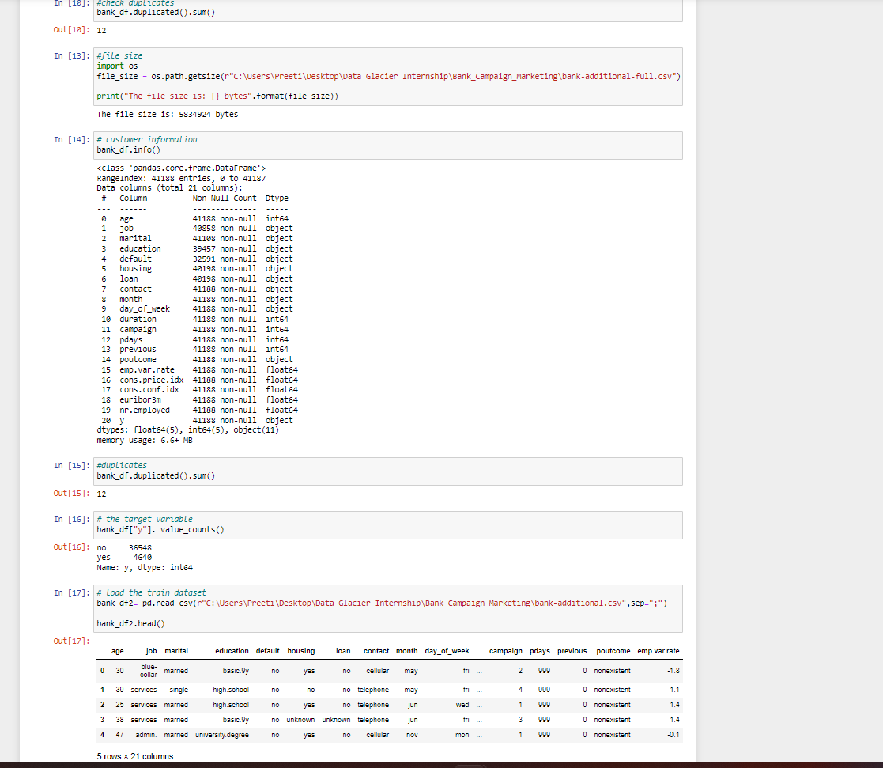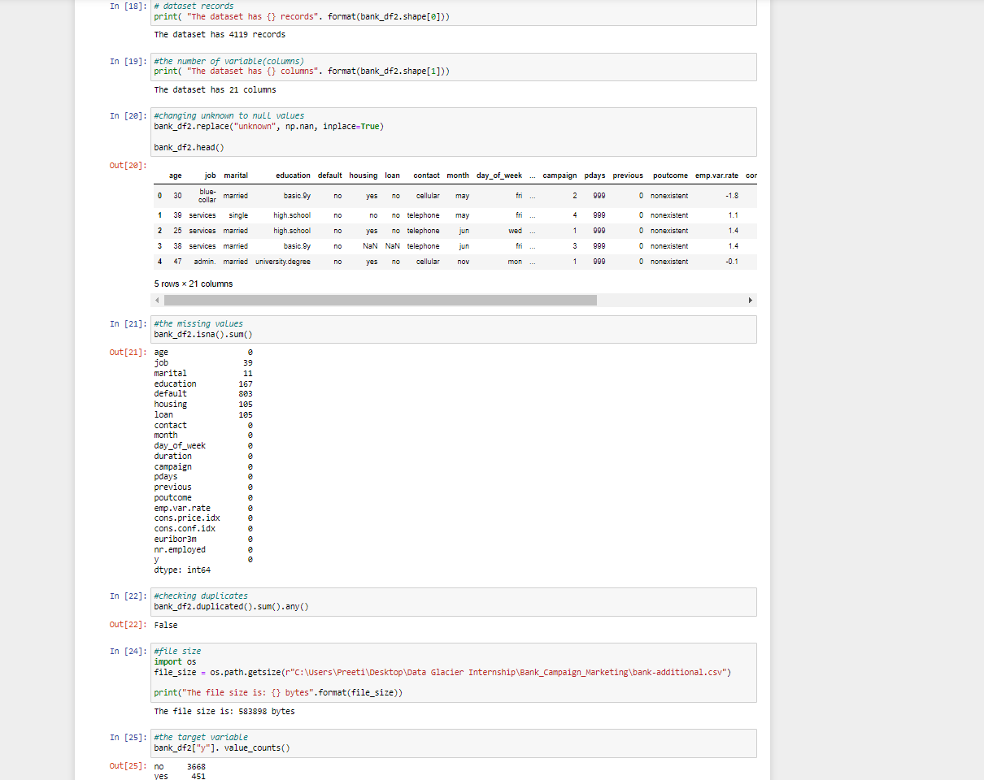

Hope this will help

**Week 8 work:**

**Virtual Internship**

**Data Science**

**Data Intake Report**

**Group Name: LISUM19: Data science Group 1**

**Members:**

| **No** | **Name** | **Email** | **Country** | **Specialization** |
| --- | --- | --- | --- | --- |
| **1** | **Preeti Verma** | [**vermapreeti.dataanalyst@gmail.com**](https://canvas.instructure.com/courses/6289580/users/37824242) | **Canada** | **Data Science** |
| **2** | **Thanuja** | [**thanujayadav953@gmail.com**](https://canvas.instructure.com/courses/6289580/users/37813542) | **UK** | **Data Science** |
| **3** | **Abishek James** | [**abishekjames1998@gmail.com**](https://canvas.instructure.com/courses/6289580/users/37813527) | **Ireland** | **Data Science** |

**Name:** Bank Marketing (Campaign)

**Report date**: 19-04-2023

**Internship Batch:** LISUM19

**Data intake by:** Preeti Verma

**Data intake reviewer:** Data Glacier

**Data storage location**:

**Problem Description**:

ABC Bank wants to sell its term deposit product to customers and before launching the product they want to develop a model which helps in understanding whether a particular customer will buy the product or not (based on the customer's past interaction with the bank or other Financial Institution). This is an application of the company’s marketing data.

**Business Understanding**:

The goal is to build a Machine Learning model that helps in predicting the outcomes of each customer's marketing campaign and analyzing which features impact the outcomes will help the company understand how to make the campaign more effective. Additionally, categorizing the customer group that subscribed to the term deposit helps to determine who is more likely to purchase the product in the future, thereby developing more targeted marketing campaigns.

This can be accomplished by using an ML model that shortlists the customers with a higher possibility of purchasing the product. So marketing such as telemarketing, SMS or email marketing can concentrate only on those customers. It will save time and resources by doing this.

**Project Lifecycle**

| **Deadline ( Date/week)** | **Plan and Deliverables** |
| --- | --- |
| 19 April 2023(Week 7) | * Problem statement * Business understanding * Dataset collection |
| 26 April 2023(Week 8) | * Data understanding * Data analysis - finding null values, and outliers. * Data processing |
| 2 May 2023(Week 9) | Data cleaning and transformation |
| 9 May 2023(Week 10) | EDA and Model Recommendation |
| 16 May 2023(Week 11) | EDA Presentation and Proposed Modeling Technique |
| 23 May 2023(Week 12) | Model Selection and Building the Model |
| 30 May 2023(Week 13) | Final project report and code submission |

**Data Understanding:**

· We were provided with 2 files namely bank_additional_full.csv, and

bank_additional.csv

· The second dataset is a sample of the first dataset

· The data cover a period from May 2008 to November 2010.

· The 1st dataset (bank_additional_full.csv) contains 41188 records & 21 columns, whereas the 2nd dataset (bank_additional.csv) has 4119 records and 21 columns.

· Columns are not uniformed named for example "day_of_week", and "emp.var.rate".

· This needs to be modified for making it easier to work with

· Some of the columns’ names were changed for easy understanding.

· All variables in both datasets have the right datatypes and all variable’s unique values are fine.

· The mean age of the respondents is 40 years, the minimum age is 17years, and the maximum age is 98years

· The mean duration of the time taken talking to the respondent is 258.3 seconds, and the minimum time is 0 seconds. This will be discarded as it does not add value to our analysis

· The minimum number of contacts during this campaign was 1 contact and the maximum was 56 contacts

· pdays variable value 999 means the lapsed days before the person was conducted thus we will make this value to be zero.

· Some variables are right-skewed (e.g “age” variable) while others are left-skewed ( e.g “no_emp”)variables.

· Our aim is to predict whether the customer will buy “y” product or note based on other variable details.

**Problems in Dataset:**

· There are 12 duplicates values in the original dataset, we dropped them since they are

minimal.

· The target variable is an imbalanced class, the "no" class has more observation than the "yes" class in both datasets. We will impute it to balance during modeling.

· Missing values were recorded as Unknown, we changed them to NaN values.

· The variable “job”, “marital”, “education”, “default”, “housing”, and “loan” has missing

values.

· The missing values were imputed as follows

a. “job”, marital, default variables were imputed by the mode of the column which is a

categorical column.

b. “education” variable was imputed with “N/A”(not applicable), this means we

assumed the respondents didn’t have any formal education and thus were not applicable.

c. “housing”, and “loan” variable missing values were dropped since they were

minimal and will not affect our analysis.

· “age”, “duration”, “campaign”, “pdays”, “previous” and “cons.conf.idx” have outliers.

· We removed the outlier in the age variable since it was the only one at the extreme end with was altering the variable mean. Outliers on other variables we decided not to remove since they look genuine.

· We dropped the “contact”, and “duration” columns, they are not going to add value to our

Analysis.

· Our columns have different formats, we changed them to standard form.

